# TECHNICAL TEST

* What bugs did you find? How did you solve these and why?

1. Bug: In user section, the update button doesn’t work while editing the existing user.

Why? - As it is a button, it shouldn’t be onchange={handleSubmit} it should be onclick event for the button to work. After this change the button works fine with a toast message.

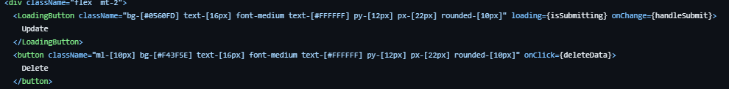Code Before:

Code After:

Result:

1. Bug: The user card did not display the name of the user which were created newly other than the sign up/sign in user, as well as it name field in the edit user page also doesn’t display the name in the field for any user.

Why? - It seems the issue might be related to how the form fields are named in the form and how they are mapped to the user object when creating a new user.

In your **Create** component, the form fields are named **username** and **email**, but when you submit the form, you're sending the values to the backend without mapping them to **name** and **email** fields.

To fix this issue, the form fields are named correctly and that the values are sent to the backend with the correct field names.

Code Before:

Code After:

Result:

1. Bug: When you click on the project which you created it shows a type error saying “Cannot read properties of undefined (reading 'toString')”

Why? - This error typically occurs when you try to access properties of an object that is **undefined**. In this case, it seems like the error is happening when trying to access the **toString** method of an undefined value, possibly within the **ProjectDetails** component.

When I try to inspect why is it undefined, I found this:

Based on the **project** object provided, it seems that you're dealing with an array containing a single object at index **0**. To access the **name** property from this object, you need to use array indexing to access the object first, and then access the **name** property from that object.

Then I tried to identify where the array is being created and changed it to a single object.

Code Before:

Code After:

Now the error is solved, and I was able to see the project page with the name of the project.

Result:

1. Bug: The edit page also had the same issue (array to object problem), saying :The error ‘Failed to load resource: the server responded with a status of 500 (Internal Server Error)’ indicates that there is an issue with the server when attempting to load the resource at the specified URL [**http://localhost:8080/project/undefined**](http://localhost:8080/project/undefined)”, and the page was not loading when I click the edit button

Doing the same, I was able to resolve the bug and see the edit page.

* Which feature did you develop and why?
  1. Validation of email ID: If a user gives invalid email id, then the user cannot create a username. With this the database will not store invalid email id structures and dummy data.

Code added:

So, if a user gives invalid format of email id, then an error message will be displayed and the user cannot submit the form.

Result:

* 1. Cancel Button while creating form: From an end user prospective while creating user or project, if he/she has change of mind they would like to cancel the form instead of creating it. So, I added cancel button in the forms.

Code added:

Result:

* Do you have any feedback about the code / architecture of the project and what was the difficulty you encountered while doing it?

No, it seems fine, while understanding and was able to figure out few bugs and sort it out. If given more time I would like to explore more on activities part.